Q1) WAP to prompt and read a line of text with words separated by space. Tokenise and extract the words. Display them. Impement the following functions for this.

1. int tokenise(char *arr); return number of tokens to the caller

Ans.

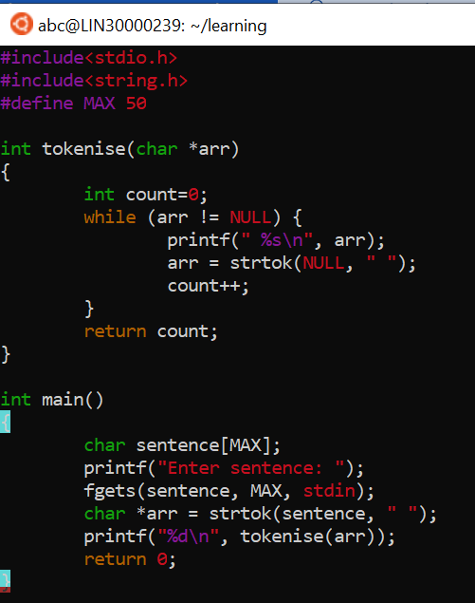

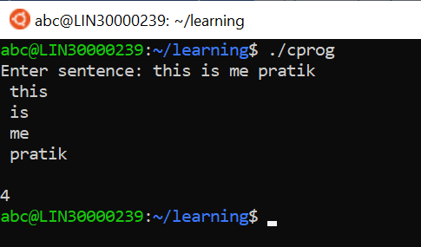

Q2) Implement your own strncat() which shall concatenate n characters from src to dest. char *strncat(char *dest, const char *src, size_t n)

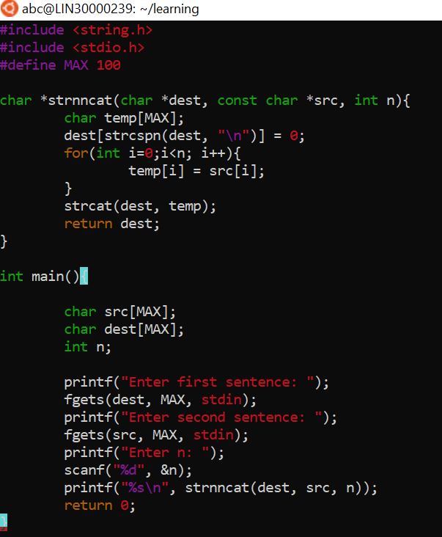

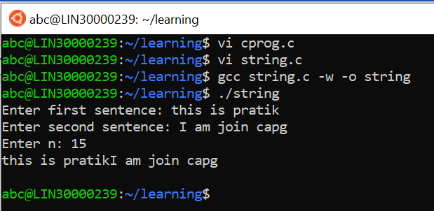

Q3) WAP to

1. Search for and replace  the vowel characters (upper and lower case) with “ay” in a word read from user. Consider a  maximum word length of 40  characters.
2. Identify the test inputs to be used
3. Display updated string

